**Kharch.AI: “AI Based Expense Tracking System”**

**PROJECT SYNOPSIS**

**OF**

**MAJOR PROJECT**

**[KCA - 451]**

**MCA – II Year / IVth Semester**

**MASTER OF COMPUTER APPLICATION**

**SUBMITTED BY**

**[GROUP NUMBER- 3]**

|  |  |
| --- | --- |
|  |  |
| |  |  |  | | --- | --- | --- | |  | **STUDENT NAME** | **ROLL NUMBER** | | **1** | Shrey Sharma | 2301650140088 | | **2** | Riya Sharma | 2301650140073 | | **3** | Kushal Mishra | 2301650140040 | | **4** | Vaibhav Mishra | 2301650140103 | |  |

**UNDER SUPERVISION OF**

**[Mr. Ajeet Singh]**

**Head of Computer Application Department**



**KANPUR INSTITUTE OF TECHNOLOGY, KANPUR**

**(DR. A.P.J ABDUL KALAM TECHNICAL UNIVERSITY, LUCKNOW)**

**DECLARATION**

We hereby declare that this submission of our own work and that, to the best of our knowledge and belief, it contains no material previously published or written by another person nor material which to a substantial extent has been accepted for the award of any other degree or diploma or the university or other institute of higher learning, except where due acknowledgement has been made in the text.

|  |  |
| --- | --- |
| **Name: Shrey Sharma**  **Roll no: 2301650140088**  **Date:**  **Signature:** | **Name: Vaibhav Mishra**  **Roll no: 2301650140103**  **Date:**  **Signature:** |
| **Name: Riya Sharma**  **Roll no: 2301650140073**  **Date:**  **Signature:** | **Name: Kushal Mishra**  **Roll no: 2301650140040**  **Date:**  **Signature:** |
|  |  |

**Approved By:**

**Mr. AJEET SINGH**

**Project Coordinator**

Head, Dept. of Computer Application

Kanpur Institute Of Technology, Kanpur

|  |  |  |
| --- | --- | --- |
| Sr.No. | **Contents** | **Page No** |
| 1 | Introduction | 4 |
| 2 | Objectives | 5 |
| 3 | Advantages | 6 |
| 4 | Project Category | 7 |
| 5 | Tools/ Platform | 8 |
| 6 | Hardware & software requirements | 9 |
| 7 | Feasibility Study | 11 |
| 8 | Complete Structure | 12 |
| 9 | Data Modeling (ER Structure) | 14 |
| 10 | Modules of the Project | 16 |
| 11 | Future Scope | 17 |
| 12 | Conclusion | 19 |
| 13 | Bibliography | 20 |

**KHARCH.AI**

**“AI BASED Expense Tracking System”**

**Introduction**

In today's fast-paced world, managing personal finances efficiently is more challenging than ever. Traditional methods of tracking expenses, often reliant on manual entry, can be time-consuming and error-prone. To address these challenges, our project, **Kharch.AI – AI-Powered Expense Tracker**, proposes an innovative solution that leverages artificial intelligence to automate expense management.

Kharch.AI simplifies the process of recording daily transactions by allowing users to input expenses via voice or text. The system employs advanced AI techniques to extract key details such as the amount, item, date, and automatically categorize each expense. Furthermore, it provides insightful financial reports and personalized suggestions to help users optimize their spending and achieve their savings goals.

By integrating intuitive user interfaces with intelligent backend processing, Kharch.AI aims to make financial management effortless and accessible for individuals, students, and small businesses alike. This project not only streamlines expense tracking but also empowers users with real-time insights and actionable recommendations, ultimately contributing to better financial decision-making.

**Objective**

The primary objective of **kharch.ai** is to develop an AI-powered expense tracking system that simplifies personal finance management through automation and intelligent insights. The system aims to eliminate the need for manual expense entry and provide users with a seamless, interactive, and efficient way to track their spending.

Key objectives of **kharch.ai** include:

1. **Automated Expense Entry** – Enable users to input expenses through text or voice commands, reducing the effort required for manual logging.
2. **AI-Based Categorization** – Automatically classify expenses into predefined categories (e.g., food, travel, entertainment) and create new categories when necessary.
3. **Real-Time Data Processing** – Store and process expense data efficiently using a secure backend, ensuring quick retrieval and analysis.
4. **Financial Insights & Reports** – Provide users with AI-driven financial reports, spending patterns, and personalized savings recommendations.
5. **Interactive AI Chatbot** – Integrate an AI-powered chatbot that assists users with queries, spending tips, and financial management advice.
6. **User-Friendly Interface** – Design an intuitive and visually appealing UI to ensure ease of use across different devices.
7. **Data Security & Privacy** – Implement encryption and authentication mechanisms to protect user data.
8. **Multi-Platform Support** – Develop the system to be accessible via web and mobile platforms for maximum usability.

By achieving these objectives, **kharch.ai** aims to revolutionize expense tracking, making financial management smarter, faster, and more accessible.

**ADVANTAGES**

**kharch.ai** offers several advantages that make expense tracking more efficient, intelligent, and user-friendly:

1. **Automated Expense Logging** – Users can enter expenses using voice or text input, reducing manual effort and ensuring accurate tracking.
2. **AI-Based Categorization** – The system automatically assigns expenses to appropriate categories and creates new ones if necessary, minimizing user intervention.
3. **Smart Financial Insights** – Provides personalized recommendations, spending trends, and budget management tips based on user data.
4. **Time-Saving** – Eliminates the need for manual entry and categorization, saving users significant time in managing their finances.
5. **Interactive AI Chatbot** – Offers instant responses to queries, financial advice, and spending alerts, making the app more engaging and helpful.
6. **Multi-Platform Accessibility** – Available on both mobile and web platforms, allowing users to access their expense data anytime, anywhere.
7. **Data Security & Privacy** – Ensures secure storage and encryption of user data, maintaining confidentiality and preventing unauthorized access.
8. **Custom Reports & Analytics** – Generates insightful reports and graphical representations of spending patterns, helping users make informed financial decisions.
9. **Personalized User Experience** – AI adapts to user preferences, offering a more customized and intuitive experience over time.
10. **Better Financial Management** – Encourages disciplined spending habits, helping users stay within their budget and plan expenses effectively.

With these advantages, **kharch.ai** enhances financial awareness and empowers users to take better control of their expenses with minimal effort.

**PROJECT CATEGORY**

**AI Based Expense Tracking System**

The **kharch.ai** application falls under the category of **Artificial Intelligence (AI)-Powered Financial Management System**. It combines the fields of:

1. **Artificial Intelligence & Machine Learning** – AI is used for automatic expense categorization, pattern recognition, and personalized financial insights.
2. **Financial Technology (FinTech)** – The application focuses on smart expense tracking, budget management, and financial analytics to enhance personal finance management.
3. **Web and Mobile Application Development** – The project involves developing a cross-platform application that can be accessed via web and mobile interfaces for user convenience.
4. **Natural Language Processing (NLP)** – Enables users to input expenses using natural language (voice or text), making the experience more interactive and intuitive.
5. **Database Management System (DBMS)** – Efficient storage and retrieval of user expenses, categories, and analytics reports using structured database management techniques.
6. **Cloud Computing** – The system may leverage cloud services for data storage, AI model training, and accessibility across multiple devices.

Since the project integrates AI, FinTech, and modern application development, it represents a **smart expense-tracking system** that enhances user financial awareness and budgeting habits.

**Tools/Platform**

**1. Programming Languages:**

* **Python:** Used for backend development.
* **Dart:** Used for frontend development with Flutter.

**2. Frontend Development:**

* **Flutter:** A cross-platform UI toolkit for building the mobile application.
* **Material UI / Cupertino UI:** To provide a seamless and attractive UI experience.

**3. Backend Development:**

* **Flask:** A lightweight Python web framework for API development.
* **FastAPI (Optional):** If needed for better async support and performance.

**4. Database Management:**

* **MySQL:** A relational database to store user expenses and categories.
* **Firebase Firestore (Alternative):** A NoSQL database for cloud-based data storage.

**5. AI & NLP Integration (Using Pre-Built Models):**

* **Google Cloud NLP / OpenAI API:** For Natural Language Processing (NLP) to understand expense entries.
* **Speech-to-Text API (Google / Azure / IBM Watson):** For processing voice input of expenses.

**6. Cloud & Hosting Services:**

* **Google Cloud / AWS / Firebase:** For database and API hosting.
* **Heroku / Render:** For hosting backend services.

**7. Development & Testing Tools:**

* **Git & GitHub:** Version control and collaboration.
* **Postman:** API testing and debugging.
* **Jupyter Notebook (For API Testing):** To test NLP and Speech-to-Text integration.

**8. Design & Documentation:**

* **Draw.io / StarUML:** For system design diagrams (ER, DFD, Class Diagrams).
* **Google Docs / LaTeX:** For project documentation and synopsis writing.

**Hardware/Software Requirements**

**1. Hardware Requirements**

**For Development:**

* **Processor:** Intel i5 or AMD Ryzen 5 (or higher)
* **RAM:** Minimum 8GB (16GB recommended for smooth multitasking)
* **Storage:** Minimum 256GB SSD (512GB SSD recommended)
* **Graphics Card:** Integrated GPU is sufficient, but a dedicated GPU can enhance performance for AI processing
* **Internet Connection:** Required for API integrations, cloud services, and version control

**For End Users (Mobile Application):**

* **Device:** Android smartphone (Android 8.0 and above) or iPhone (iOS 12 and above)
* **RAM:** Minimum 3GB (Recommended: 4GB or higher)
* **Storage:** 100MB free space for installation
* **Microphone:** Required for voice input feature

**2. Software Requirements**

**For Development:**

* **Operating System:** Windows 10/11, macOS, or Linux
* **Code Editor:**
  + VS Code (Recommended)
  + PyCharm (for Python backend)
  + Android Studio (for Flutter frontend)
* **Backend Framework:** Flask (Python)
* **Frontend Framework:** Flutter (Dart)
* **Database Management System:** MySQL / Firebase Firestore
* **Cloud Services (Optional):** Google Cloud / AWS / Firebase
* **Version Control:** Git & GitHub
* **Testing Tools:** Postman (for API testing), Jupyter Notebook (for AI API testing)

**For End Users:**

* **Mobile Application:** Kharch.ai (to be installed from Play Store / App Store)
* **Internet Connection:** Required for syncing data with the cloud and AI-based expense categorization.

**Software Requirement Specifications**

**Functional Requirements (FR)**

| **ID** | **Requirement** | **Description** |
| --- | --- | --- |
| FR1 | User Authentication | Users can register, log in, and manage accounts. |
| FR2 | Voice Expense Input | Users can add expenses by speaking. |
| FR3 | Text Expense Input | Users can manually enter expenses. |
| FR4 | AI-Based Categorization | AI assigns expenses to predefined or new categories. |
| FR5 | Dynamic Category Creation | AI creates new categories if necessary. |
| FR6 | AI-Based Financial Tips | The system provides **personalized savings tips** based on spending patterns. |
| FR7 | AI Chatbot for Assistance | Users can interact with a chatbot for **financial guidance & queries**. |
| FR8 | Expense Editing | Users can modify past expenses. |
| FR9 | Report Generation | The system provides analytics & reports. |

**2.2 Non-Functional Requirements (NFR)**

| **ID** | **Requirement** | **Description** |
| --- | --- | --- |
| NFR1 | Performance | Process voice input as fast as it can. |
| NFR2 | Security | Use better **encryption** for data storage. |
| NFR3 | Scalability | Support **multiple users** concurrently. |
| NFR4 | Availability | Ensure available **uptime** with cloud hosting. |
| NFR5 | AI Accuracy | AI must achieve **85%+ accuracy in categorization**. |

**Feasibility Study**

1. **Technical Feasibility**

* **Tech Stack**: Flutter (Frontend), FastAPI + PostgreSQL (Backend), AI with Python (ML/NLP)
* **AI Features**: Smart spending insights, chatbot for financial advice, expense categorization
* **Cloud Hosting**: AWS / Firebase / Railway (Scalable & Secure)
* **Challenges**: Training an accurate AI model for personalized expense analysis , Ensuring data security & compliance (GDPR, PCI-DSS)

1. **Economic Feasibility**

* **Revenue Model**: Freemium Model (Basic free, premium AI insights) / Subscription-based (₹99-₹499/month) /Affiliate partnerships (banks, fintech apps)
* **ROI (Return on Investment)**: Break-even in 6-12 months with good user adoption

1. **Market Feasibility**

* **Target Audience**: Students, working professionals, freelancers, small business owners
* **Competitors**: Walnut, Goodbudget, Spendee (Expenzo differentiates with AI + Chatbot)
* **Unique Selling Points (USP):** AI-driven analysis, Interactive chatbot, Multi-platform accessibility

1. **Operational Feasibility**

* Solo or small team can build MVP in 3-4 months
* Marketing via social media, student networks, and fintech collaborations
* Customer Support: Telegram/WhatsApp group, FAQs, chatbot assistance

1. **Legal & Ethical Feasibility**

* Compliance with data privacy laws (GDPR, Indian IT Act 2000)
* Secure authentication (OAuth, Firebase Auth, JWT)

**Complete Structure of the Kharch.AI**

1. **Use Case Diagram:** 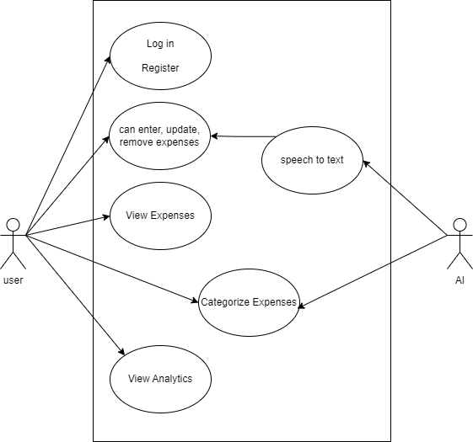
2. **Class Diagram:** 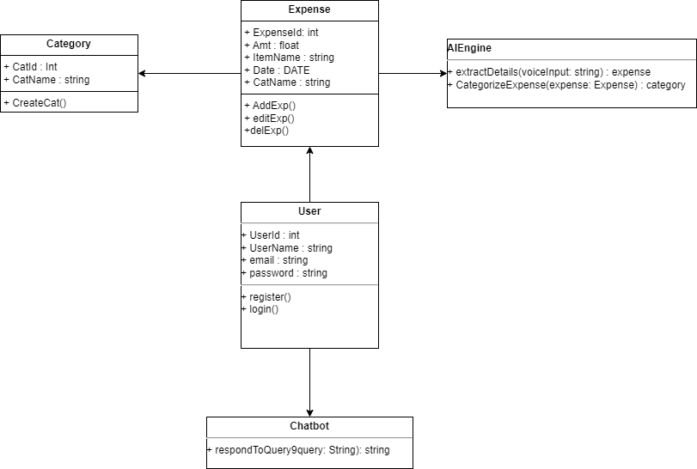
3. **Data Flow Diagram:**

**Level zero:**

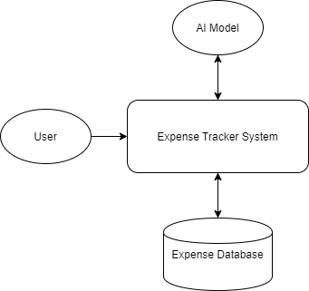

**Level 1:**

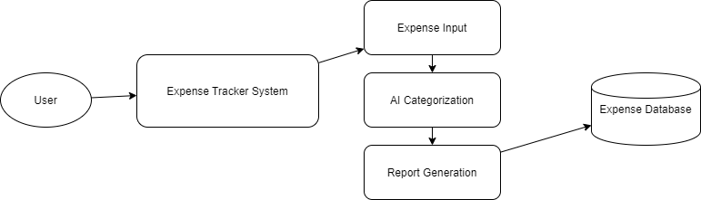

**Level 2:**

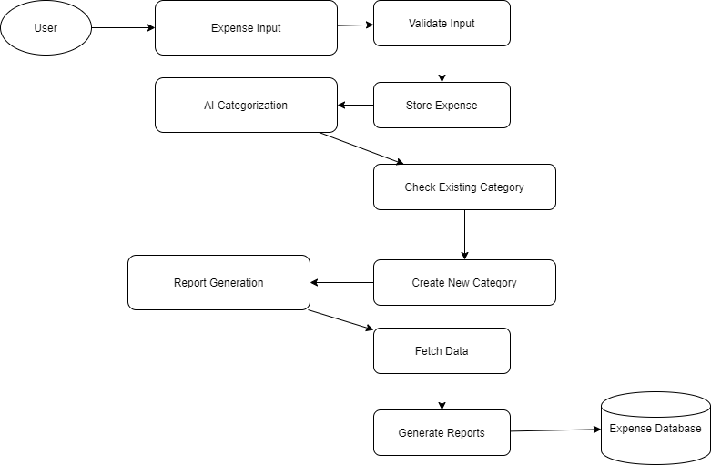

1. **ER Structure:**

**Entities & Attributes**

1. **User** (User_ID is PK)

* Name
* Email
* Password
* Currency Preference
* Budget Limit

1. **Expense** (Expense_ID is PK, User_ID is FK, Category_ID is FK)

* Amount
* Date
* Description
* Payment Method

1. **Category** (Category_ID is PK, User_ID is FK for custom categories)

* Name

1. **AI Model** (AI_ID is PK)

* Algorithm Used
* Last Training Date
* Accuracy Rate

1. **Report** (Report_ID is PK, User_ID is FK)

* Month/Year
* Total Expenses
* Savings
* AI Insights

1. **Suggestion** (Suggestion_ID is PK, User_ID is FK, Expense_ID is FK [optional])

* Suggestion Text
* Date

**Relationships & Cardinalities**

1. **User → Expense** (**1:M**)

* A user **can have multiple expenses**, but an expense **belongs to only one user**.

1. **Expense → Category** (**M:1**)

* An expense **belongs to one category**, but a category **can have multiple expenses**.

1. **User → Category** (**1:M** for custom categories)

* If users can create custom categories, **each user can create many categories**, but a category belongs to **one user**.

1. **AI Model → Category** (**1:M**)

* AI Model **predicts and assigns** categories.

1. **User → Report** (**1:M**)

* A user **receives multiple reports** over time.

1. **Report → Suggestion** (**1:M**)

* A report **can generate multiple suggestions**.

1. **Expense → Suggestion** (**M:1** [optional])

**MODULES OF THE PROJECT**

1. **User Authentication & Profile Management**
   * User registration and login (Google/Facebook authentication)
   * Secure session management
2. **Expense Logging**
   * Manual text input for expenses
   * Voice-based expense entry
3. **AI-based Expense Categorization**
   * AI automatically assigns categories to expenses
   * Creation of new categories if needed
4. **Expense Dashboard & Reports**
   * Monthly, weekly, and daily expense summaries
   * Visual charts and graphs
5. **Budget Management**
   * Users can set spending limits
   * Alerts and notifications for overspending
6. **Data Backup & Security**
   * Cloud-based storage for backup and synchronization
   * Secure encryption for user data
7. **AI-based Financial Insights**
   * AI-driven suggestions on savings and budgeting
   * Expense trend analysis

**FUTURE SCOPE**

Kharch.ai is designed to be an intelligent expense management system with AI-powered insights. As technology advances and user needs evolve, the application has the potential to expand in various ways. The following are key areas for future improvements and developments:

**1. Advanced AI-Powered Financial Analysis**

* Enhancing AI algorithms to provide **deeper insights into spending habits** and **predict future expenses** based on user behavior.
* Implementing **machine learning models** to offer **personalized saving plans** based on income, expenses, and financial goals.

**2. Automated Expense Tracking & Integration**

* **Bank and UPI Integration**: Automatically fetch and categorize transactions by linking with bank accounts, UPI, and digital wallets.
* **Receipt Scanning & OCR**: Implement Optical Character Recognition (OCR) to extract data from uploaded bills and receipts.

**3. Multi-User & Family Budgeting System**

* Introduce a **shared budgeting feature** where families or business teams can manage and track expenses together.
* Assign different access levels for **admins and members** for better control over group finances.

**4. Smart Financial Assistant**

* Develop a **voice-enabled chatbot** to assist users in managing their expenses, providing spending alerts, and answering financial queries.
* Implement **AI-powered reminders** for bill payments, investment opportunities, and budget adjustments.

**5. Cross-Platform Availability**

* Expanding Kharch.ai to **iOS, Web, and Desktop applications** to enhance accessibility.
* Implementing **progressive web apps (PWA)** to allow offline expense tracking.

**6. Investment & Financial Planning Integration**

* Provide **investment recommendations** based on expense patterns and savings.
* Enable users to **set and track financial goals** such as home loans, car loans, or travel savings.

**7. Global Expansion & Multi-Currency Support**

* Supporting **multiple currencies** and providing localized financial insights for users in different countries.
* Implementing **currency exchange rate tracking** for travelers and international users.

**8. Blockchain-Based Security & Transparency**

* Implement **blockchain technology** for secure and transparent financial transactions.
* Enable **smart contracts** for automated financial agreements and secure expense-sharing among users.

**9. Integration with Government & Tax Systems**

* Providing **automated tax calculation** and **GST invoice generation** for freelancers and businesses.
* Helping users track tax-deductible expenses and generate reports for easy tax filing.

**10. Subscription-Based Premium Features**

* Introduce a **freemium model** with advanced financial analytics, investment tracking, and premium support for paid users.
* Offer **custom financial consultation** services for users seeking expert advice on expense management.

**Conclusion**

Kharch.ai is an innovative AI-powered expense tracking and management application designed to simplify financial planning and provide intelligent insights into users' spending habits. By leveraging artificial intelligence, automation, and a user-friendly interface, Kharch.ai offers a seamless experience for individuals looking to manage their expenses efficiently.

In the current digital age, financial awareness and expense management have become essential for individuals, families, and businesses. Traditional methods of tracking expenses, such as manual bookkeeping or basic spreadsheets, are time-consuming and prone to human errors. Kharch.ai addresses these challenges by introducing AI-driven automation, categorization, and personalized financial recommendations, making expense management effortless and insightful.

One of the key highlights of Kharch.ai is its **AI-based expense categorization and smart suggestions**, which help users gain a clear understanding of their financial habits. The integration of **voice-based input**, AI-powered reports, and automated insights ensures that users can track their finances with minimal effort. Furthermore, features such as **budget setting, savings analysis, and AI-driven financial planning** enhance the overall experience and empower users to make informed financial decisions.

As financial technologies evolve, Kharch.ai has a promising future with potential enhancements, such as **bank and UPI integration, investment tracking, multi-user family budgeting, and blockchain-based security**. The incorporation of tax calculations, personalized financial consultations, and global multi-currency support further positions Kharch.ai as a future-ready financial assistant.

By continuously improving its capabilities and adapting to modern financial needs, Kharch.ai aspires to become a **comprehensive financial management tool** for users worldwide. Whether an individual looking to control daily expenses or a small business managing financial transactions, Kharch.ai serves as an intelligent and reliable assistant.

With its **AI-driven automation, smart suggestions, and seamless user experience**, Kharch.ai is set to revolutionize personal finance management, making it easier and more efficient for users to take charge of their financial well-being.

**BIBLIOGRAPHY**

* Flutter Documentation: <https://flutter.dev/docs>
* OpenAI. (2024). "AI in Financial Technology: Opportunities & Challenges." Retrieved from <https://openai.com>
* Google AI Blog. (2024). "Deep Learning in Expense Categorization." Retrieved from <https://ai.googleblog.com>
* IBM Cloud. (2023). "Building AI-Powered Applications for Finance." Retrieved from <https://www.ibm.com/cloud>
* Flask Documentation. (2024). "Developing REST APIs with Flask." Retrieved from <https://flask.palletsprojects.com>
* MySQL Documentation. (2024). "Database Management for Financial Applications." Retrieved from <https://dev.mysql.com>
* Draw.io. (2024). "Designing ER Diagrams for Expense Tracking Systems." Retrieved from <https://www.draw.io>
* Python Software Foundation. (2024). "Using Python for AI-Powered Applications." Retrieved from <https://www.python.org>
* NITI Aayog. (2023). Artificial Intelligence for India: Opportunities and Challenges in FinTech.